iteration 4 report: Find tutor

github: <https://github.com/anminfang-tamu/tamu-find-tutor>

heroku: <https://tamu-find-tutor.herokuapp.com/> use <https://tamu-find-tutor.herokuapp.com/users> to see current users and use ​​ [https://tamu-find-tutor.herokuapp.com/](https://tamu-find-tutor.herokuapp.com/users)users/new to add user

pivotal tracker: <https://www.pivotaltracker.com/n/projects/2556191>

1. customer meeting

Date: 4/21 Wed

Duration: 10 mins

Discussion content: We just discussed recent progress. We told client that we have finished the research function.

1. User stories implemented

Last time, we left two user stories of adding a search function. we have implemented two user stories in this iteration:

2.1 search post: to allow users to search some topics in post. Thus they could find the postes they are interested in. It was divided into several tasks, as search controller design, search function in model and redirect in top_bar.

2.2 search post: to allow users to search some specific tutor. Almost the same as search post. Thus, they could find the tutor they are interested in. We implemented by adding a search method in user model.

1. Rspec test

We used rspec to develope some test cases for our model, controller. Factories, helper, request and view. The simplecov coverage is as follow(the result can also be seen in document/spring2022/simplecov.html:

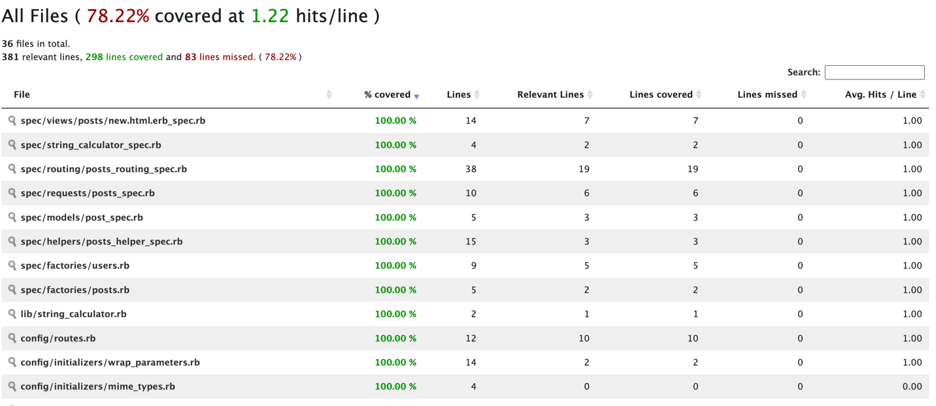

1. relational database diagram

We created two models: user and post. Post has user_id as foreign key. The relationship between user and post is as:

